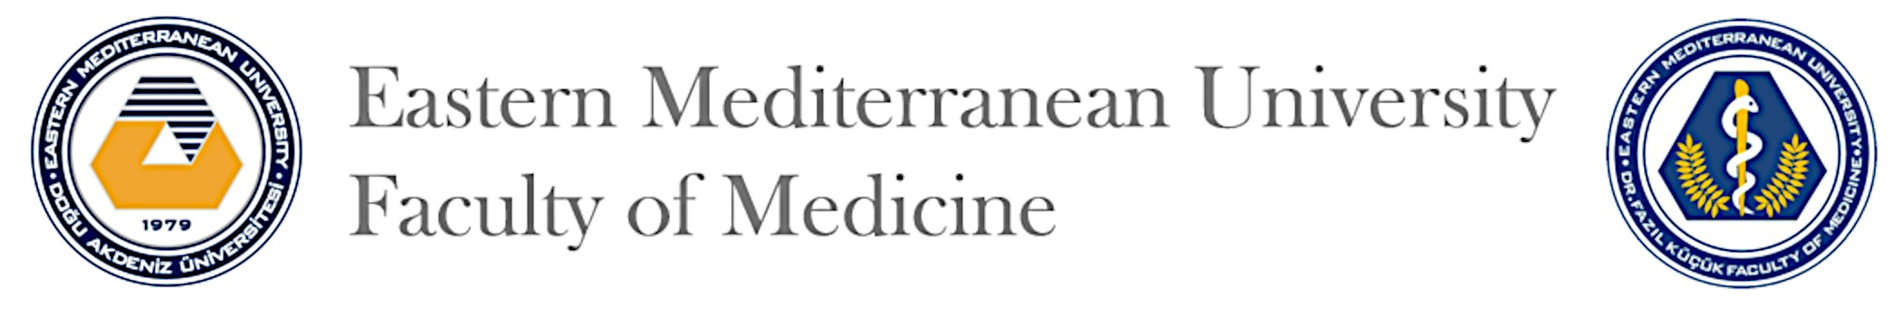
NEW STUDENT REGISTRATION FORM
Student Number:
Student Name:

Courses to be taken for the first year:
Code | Course Name | T | P | C | Registration status | Exemption
MEDN110 | Introduction to Cell and Cellular Replication | 105 | 12 | 9
MEDN120 | Cellular Metabolism and Transport | 106 | 12 | 9
MEDN130 | Development and Organization of Human Body | 107 | 11 | 10
MEDN140 | Introduction to Nervous System and Human Behavior | 124 | 18 | 11
MEDN160 | Introduction to Clinician Skills – I | 40 | 45 | 9
ENGL131 | Medical English | 47 | 0 | 4
HIST180 | Ataturk’s Principles and History of Modern Turkey (for Turkish Students) | 52 | 0 | 4
TFMS101 | Turkish for Medical Students – I (for foreign students) | 56 | 20 | 4
TFMS102 | Turkish for Medical Students – II (for foreign students) | 56 | 20 | 4
UE – 01 | Phase 1: Elective I (for Turkish students)  ............................................................. | 56 | 20 | 4

Courses to be taken from outside the first year:

.................................................. ...........................................................
Asst. Prof. Dr. Ergül Mutlu Altundağ Yönter Meray
Year 1 Coordinator and Student Advisor Student Affairs Coordinator

